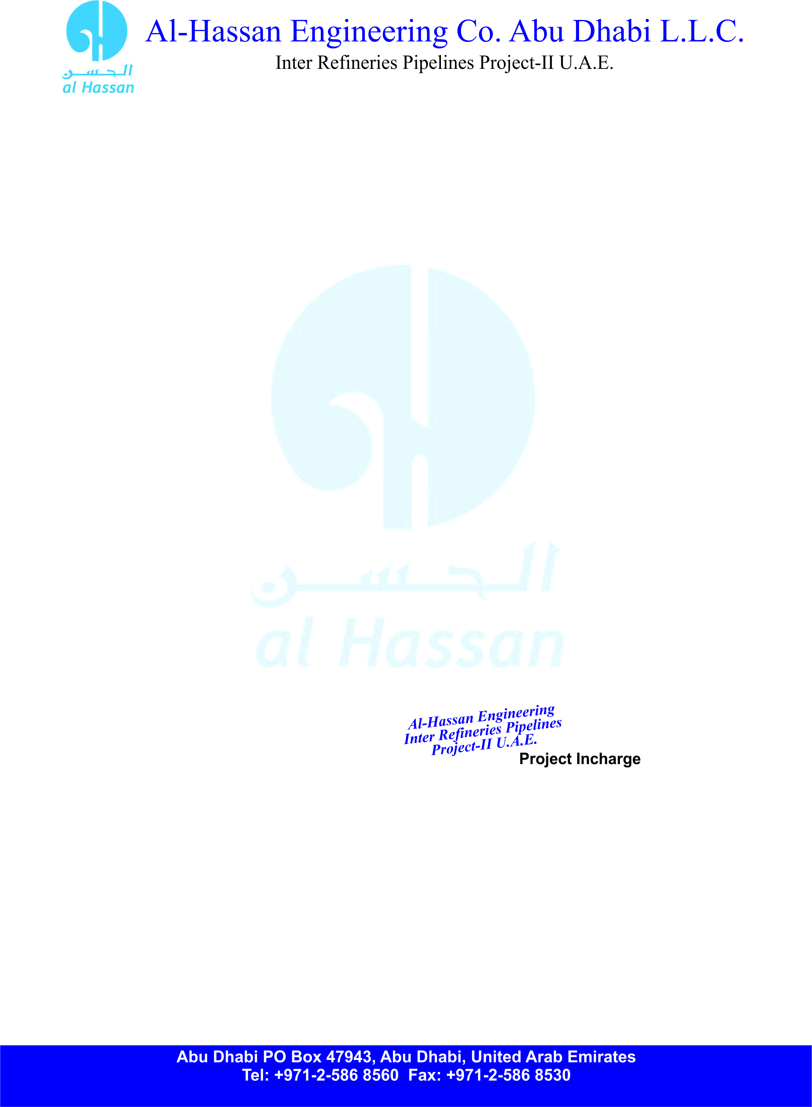

**ID NO: AEHC-558**

**TO WHOM IT MAY CONCERN**

**Certified that Mr. <Name> S/O Mr. <fname> worked with us as a <Designation> at Inter Refineries Pipeline Project-II U.A.E. from <From> to <To>.**

**During his services period we found him hardworking intelligent and having vast experience in this field.**

**He left the services on his own accord.**

**We wish him every success in his future career.**

